COVID VACCINE ANALYSIS

Data Analytics with cognos – Phase 5 DOCUMENTATION

Team Members:

1.SATHANA S(au613021205046)

2.RAMYA R(au613021205038)

3.RASIGA J(au613021205040)

4.KAVIYA R(au613021205024)

5.SAJEETHA BRITTY E(au613021205042)

**ABSTRACT:**

The COVID-19 pandemic, caused by the novel coronavirus SARS-CoV-2, has triggered an unprecedented global response to develop and distribute vaccines. This analysis provides a comprehensive review of COVID-19 vaccines, focusing on their efficacy, safety, distribution, and global impact. We examine the development of various vaccine platforms, including mRNA, viral vector, and inactivated vaccines, and assess their performance in real-world settings. Safety considerations, including adverse events and rare side effects, are also discussed. The paper explores the equitable distribution of vaccines worldwide and the challenges faced in ensuring global immunization. Furthermore, the analysis addresses the long-term impact of vaccination campaigns on curbing the pandemic and highlights the importance of ongoing research and surveillance in the fight against COVID-19.

**1.OBJECTIVE:**

The primary objective of this analysis is to comprehensively evaluate the COVID-19 vaccines with a focus on the following key areas:

* Efficacy Assessment: To assess the effectiveness of different COVID-19 vaccines in preventing infection, reducing the severity of the disease, and preventing hospitalization and mortality.
* Safety Evaluation: To examine the safety profiles of COVID-19 vaccines, including the identification and analysis of adverse events and potential rare side effects associated with vaccination.
* Distribution and Equity: To analyze the global distribution of COVID-19 vaccines and assess the challenges and successes in ensuring equitable access to vaccines across various regions and populations.
* Real-world Impact: To understand the real-world impact of vaccination campaigns in curbing the COVID-19 pandemic, including the reduction of transmission, public health outcomes, and economic implications.
* Future Considerations: To discuss the long-term implications of COVID-19 vaccination efforts and identify areas that require continued research and surveillance to effectively manage and control the pandemic.

This analysis aims to provide a comprehensive and evidence-based understanding of the COVID-19 vaccine landscape, aiding policymakers, healthcare professionals, and the public in making informed decisions and contributing to global efforts to combat the pandemic.

**2.DESIGN THINKING:**

1. Empathize:

   - Understand the needs and concerns of various stakeholders, including healthcare workers, researchers, policymakers, and the general public.

   - Gather qualitative and quantitative data on vaccine efficacy, safety, and distribution challenges.

2. Define:

   - Clearly define the problem statement, such as "How can we optimize the distribution and utilization of COVID-19 vaccines to maximize their impact on public health?"

   - Identify specific goals, user personas, and success criteria for the analysis.

3. Ideate:

   - Brainstorm potential research methodologies, data sources, and analytical approaches for assessing vaccine efficacy and safety.

   - Explore innovative ways to visualize and present data to make the analysis more accessible and actionable.

4. Prototype:

   - Create a preliminary plan for data collection, analysis, and reporting, outlining key milestones and timelines.

   - Develop data visualization prototypes or sample reports to test how insights can be effectively communicated.

5. Test:

   - Conduct pilot analyses to validate the chosen methodologies and data sources.

   - Collect feedback from domain experts and stakeholders to refine the analysis plan and visualization strategies.

6. Implement:

   - Execute the full-scale analysis, following the refined plan and incorporating feedback from the testing phase.

   - Ensure data integrity, quality control, and ethical considerations in data handling and analysis.

7. Iterate:

   - Continuously review and refine the analysis as new data becomes available or as the situation evolves.

   - Remain open to feedback and adapt the analysis to address emerging questions and concerns.

8. Communicate:

   - Present the analysis findings in a clear and accessible manner, using visuals, reports, or interactive tools.

   - Engage with the relevant stakeholders and the public to ensure that the insights are effectively communicated and understood.

9. Reflect:

   - Reflect on the impact of the analysis and assess how it contributes to informed decision-making and public health efforts.

   - Identify lessons learned and opportunities for future analyses or improvements in the design thinking process.

This design thinking approach aims to foster a user-centric, iterative, and innovative analysis of COVID-19 vaccines, ultimately enhancing the response to the pandemic and facilitating evidence-based decision-making.

**3.DEVELOPEMENT PHASE:**

1. Data Collection:

   - Gather relevant data from multiple sources, including clinical trials, real-world data, healthcare systems, and global health organizations.

   - Ensure data quality and accuracy, addressing issues such as missing data or inconsistencies.

2. Data Preprocessing:

   - Clean and transform data to make it suitable for analysis.

   - Handle outliers, missing values, and data normalization or standardization as needed.

**DATASET LINK :**

<https://www.kaggle.com/datasets/gpreda/covid-world-vaccination-progress>

3. Exploratory Data Analysis (EDA):

   - Perform EDA to understand the dataset's characteristics and relationships among variables.

   - Visualizations and statistical summaries help uncover patterns and trends.

**4.LOADING THE DATASET:**

1.Importing libraries Here, for preprocessing the dataset and manipulate the data, pandas is the library used to frame the data.

**Code: import pandas as pd**

2.Loading the dataset In this step, we are framing the data into the table using DataFrame in pandas, and display the head or 5 rows of the dataset.

**Code: # Replace with the actual filename**

**file_path="C:/Users/91962/Documents/country_vaccinations.csv" df = pd.read_csv(file_path)**

**5.EXPLORING THE DATA SET:**

After framing data, the first few or five rows of the data in displayed using the head() function.

**Code: print(df.head())**

**OUTPUT:**

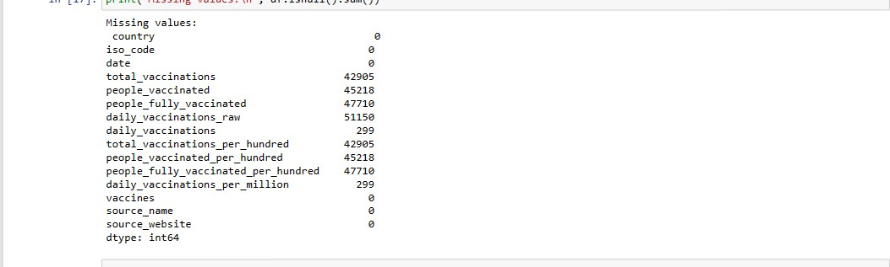

**6.DATA VISUALIZATION:**

**BAR PLOT:**

**sns.set_style("whitegrid") plt.figure(figsize= (8,8)) ax= sns.barplot(x.values)**

**ax.set_xlabel("Fully vaccinated(count)") plt.show()**

## OUTPUT:

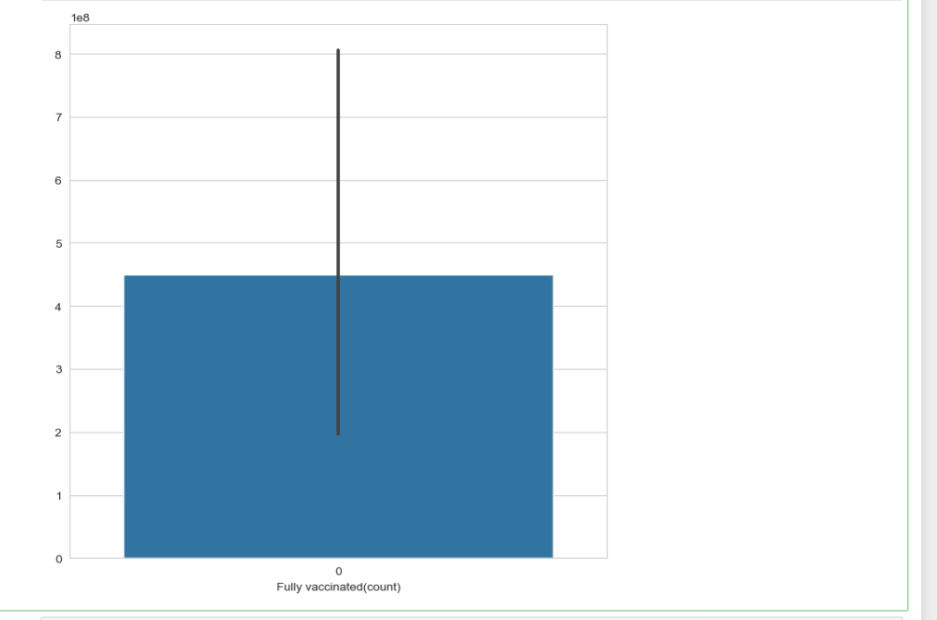

**plt.figure(figsize= (8,8)) ax= sns.barplot(x.values)**

**ax.set_xlabel("daily vaccinations(avg)") plt.show()**

## OUTPUT:

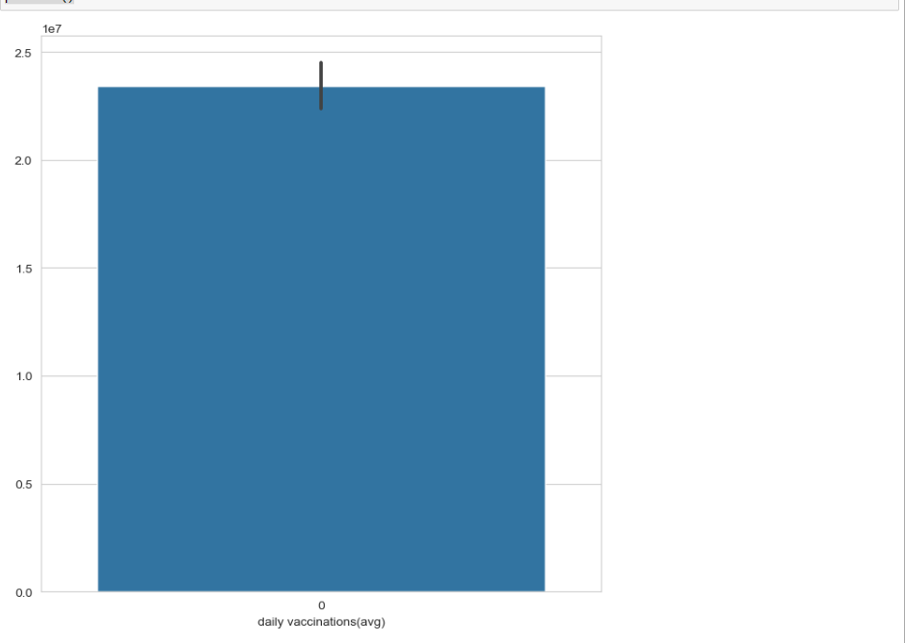

**COUNT PLOT:**

**plt.figure(figsize=(15,15)) sns.countplot(y= "vaccines",data= df) plt.show()**

## OUTPUT:

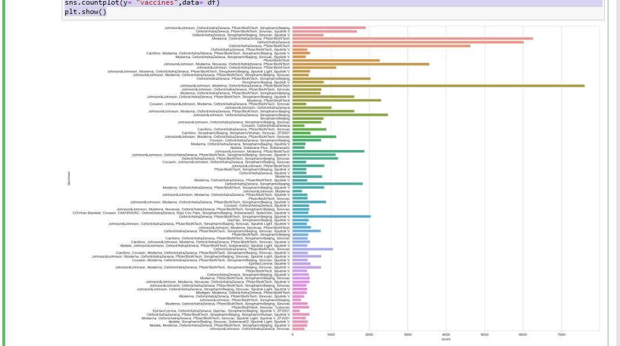

**LINE PLOT:**

**x= df.groupby("date").daily_vaccinations.sum() plt.figure(figsize= (15,5))**

**sns.lineplot(x.index) plt.show()**

## OUTPUT:

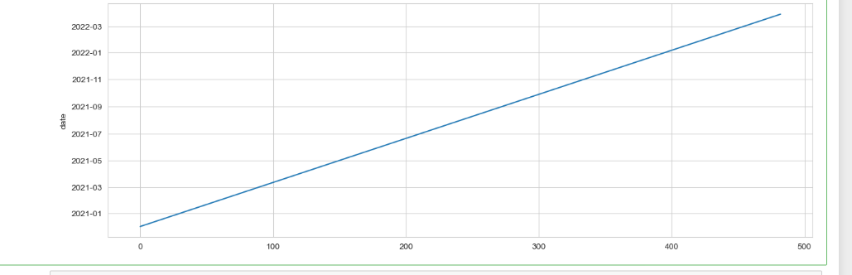

**plt.figure(figsize= (15,5))**

**sns.lineplot(x= "date",y= "total_vaccinations",data= df) plt.show()**

## OUTPUT:

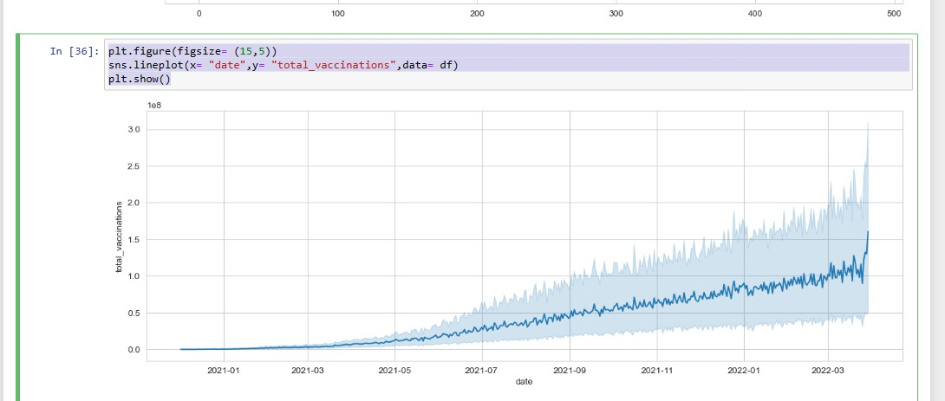

**plt.figure(figsize= (15,5))**

**sns.lineplot(x= "date",y= "daily_vaccinations_per_million",data= df) plt.show()**

## OUTPUT:

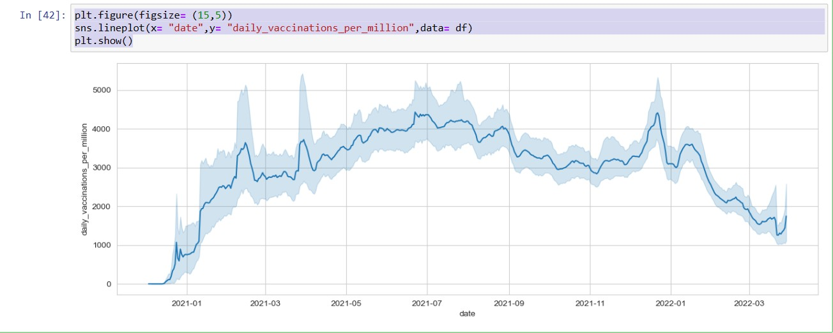

**plt.figure(figsize= (15,5))**

**sns.lineplot(x= "date",y= "total_vaccinations",data= df[df["country"]=="I ndia"])**

**plt.show()**

## OUTPUT:

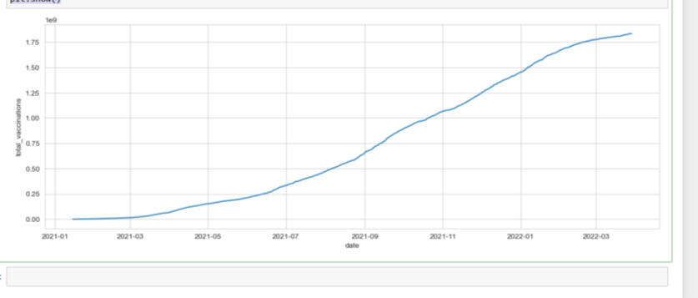

**7. DATA VISUALIZATION**

**7.1 DATA ANALYTICS WITH IBM COGNOS**

* IBM Cognos Introduction
  + - * + Introduce IBM Cognos as a tool for data analytics.

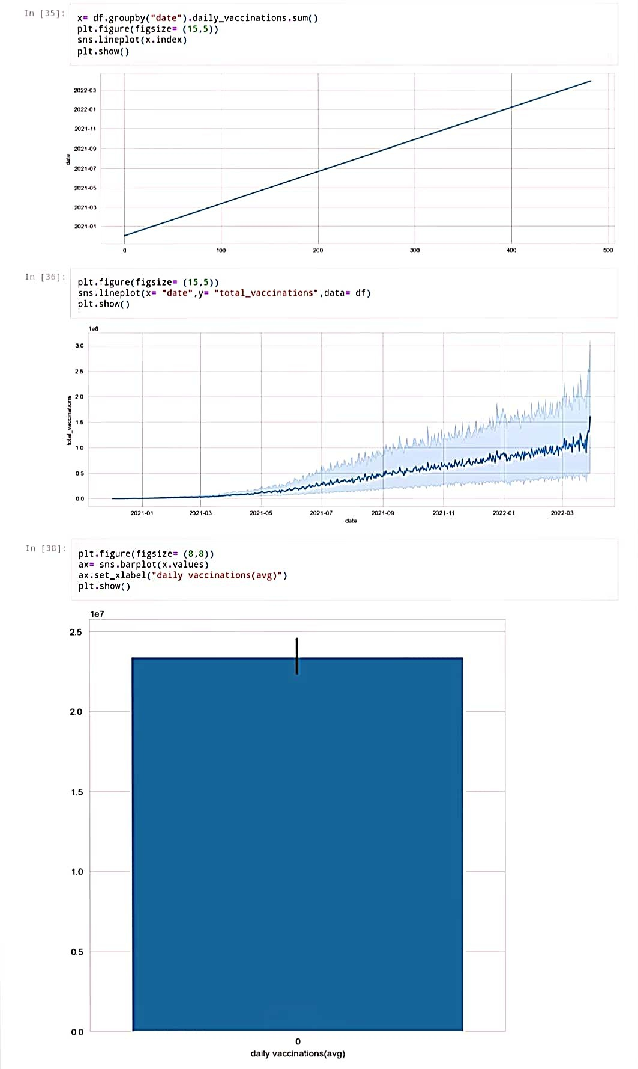

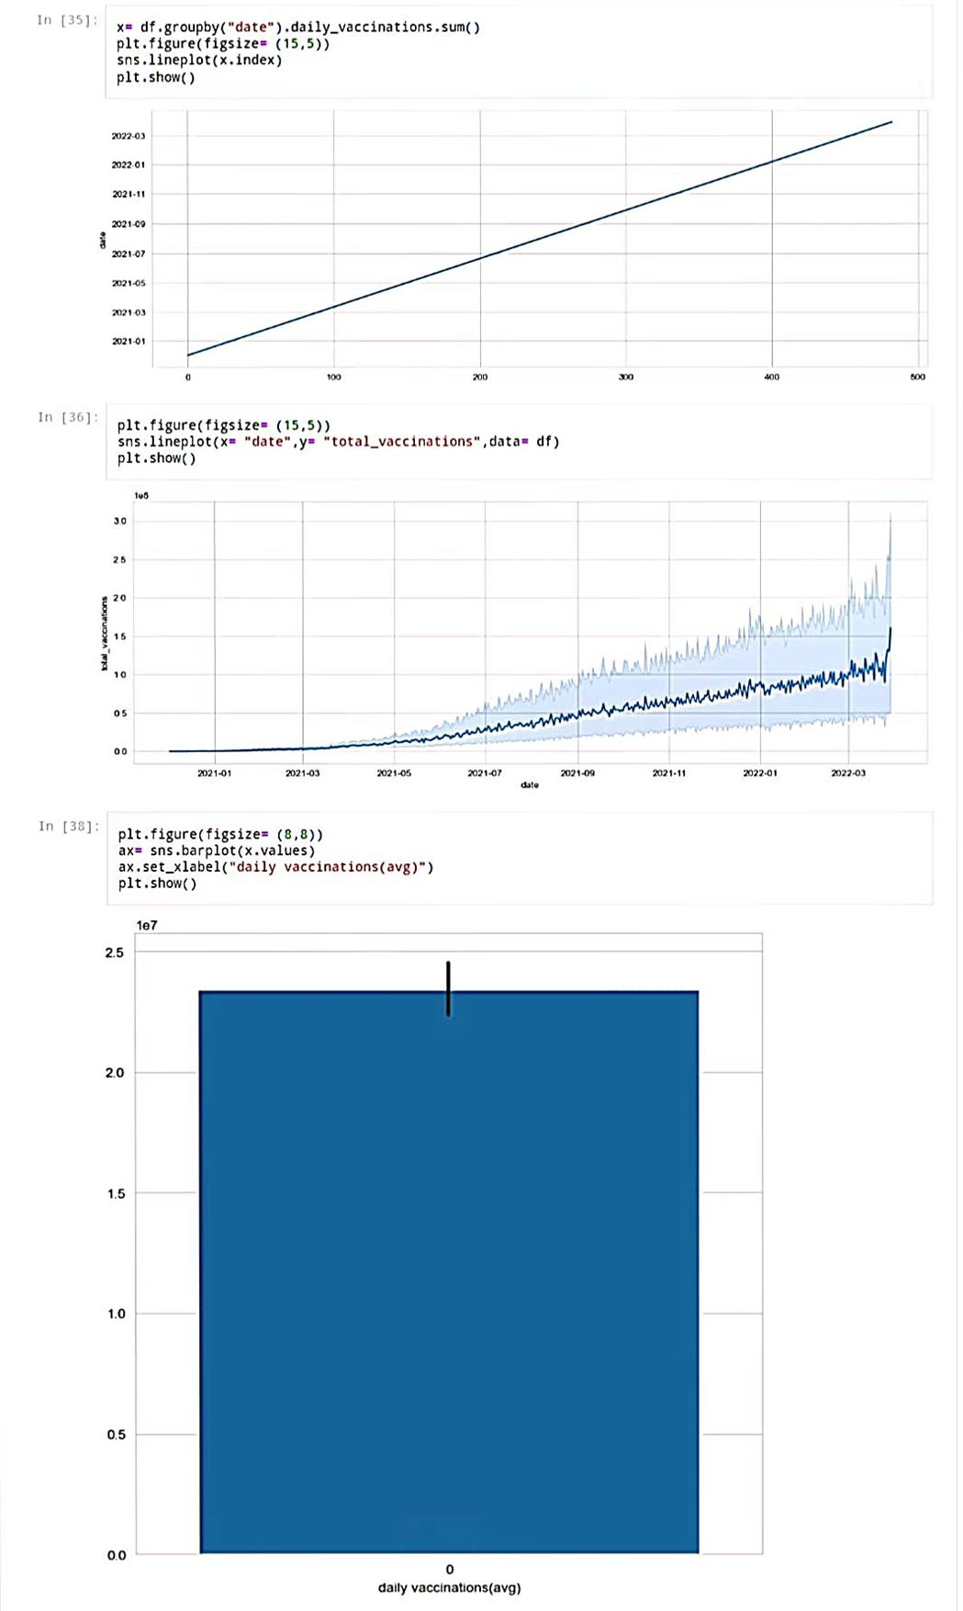



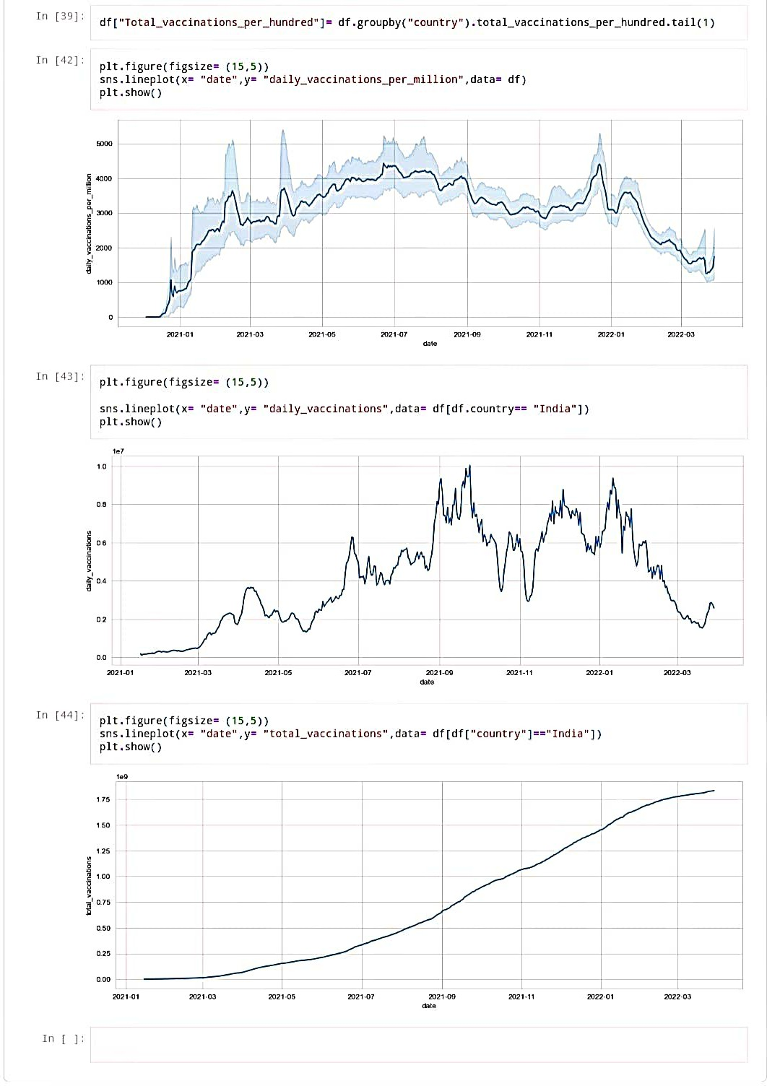

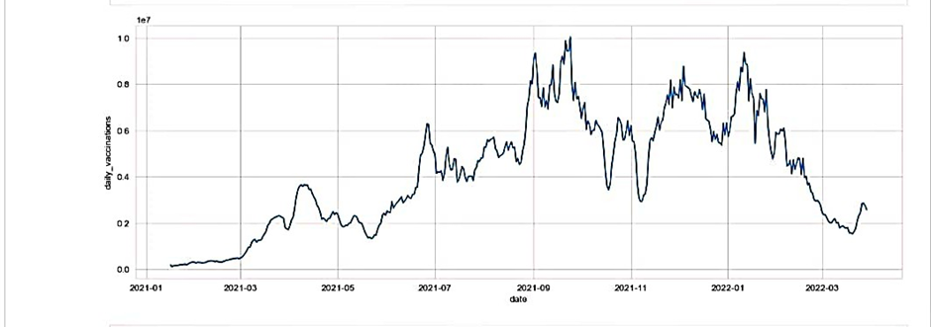

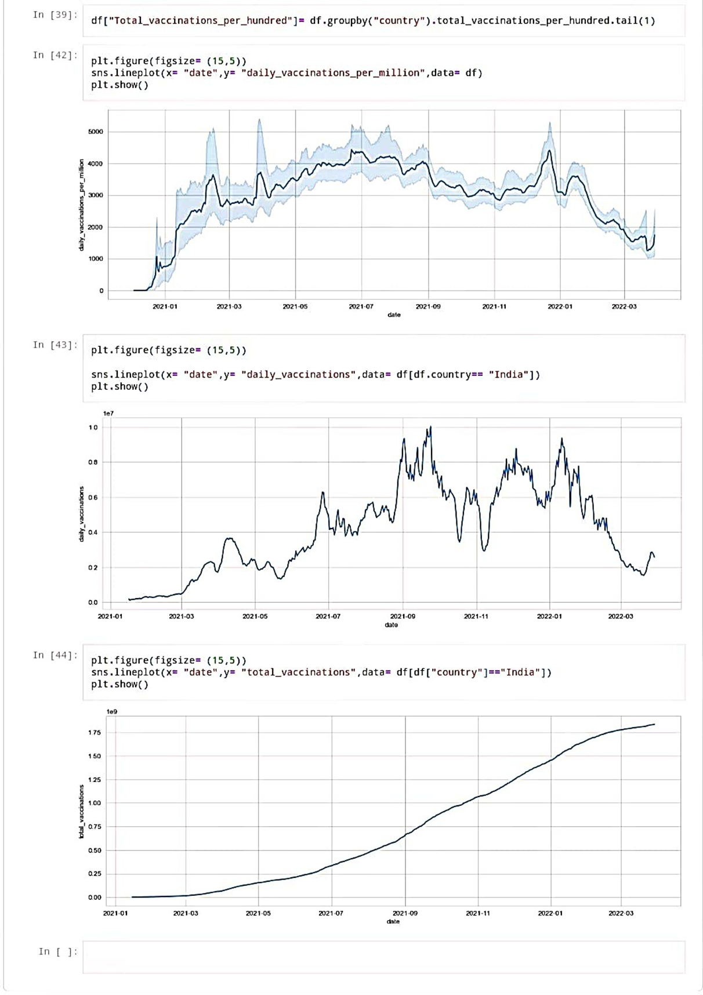

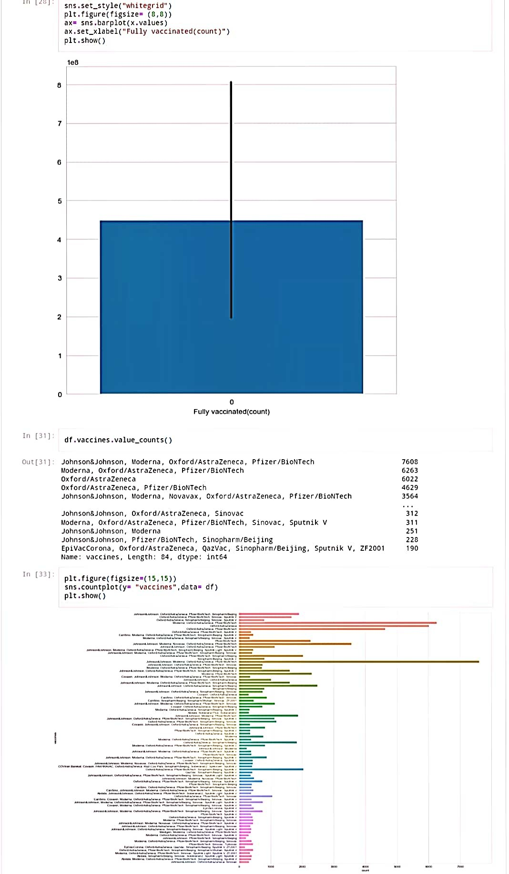

**8.PREDICTIVE MODELLING:**

Predictive modeling for COVID-19 vaccine analysis involves using data and statistical techniques to make predictions and gain insights related to vaccine efficacy, distribution, and impact. Here are some key areas where predictive modeling can be applied:

1. Vaccine Efficacy: Predictive models can estimate the effectiveness of COVID-19 vaccines by analyzing data on vaccine recipients, infection rates, and outcomes. This helps in assessing how well a vaccine prevents illness and transmission.

2. Vaccine Distribution: Models can optimize the allocation and distribution of vaccines by considering factors such as population demographics, vaccine supply, and logistics. This ensures efficient and equitable distribution.

3. Herd Immunity Estimation: Predictive modeling can be used to estimate when a sufficient portion of the population will be vaccinated to achieve herd immunity, helping plan public health strategies.

4. Vaccine Hesitancy: Models can predict and analyze vaccine hesitancy rates, identifying areas or groups where public health messaging and interventions are needed.

5. Variants and Booster Shots: Predictive models can assess the impact of emerging COVID-19 variants on vaccine effectiveness and help determine the timing and necessity of booster shots.

6. Adverse Events: Predictive modeling can monitor and analyze adverse events following vaccination to ensure vaccine safety and inform regulatory decisions.

7. Long-term Immunity: Models can project the duration of vaccine-induced immunity and the need for periodic re-vaccination.

It's crucial to base these models on high-quality data and regularly update them as new information becomes available. Public health authorities, researchers, and policymakers rely on these models to make informed decisions and manage the ongoing response to the COVID-19 pandemic.

**9.INSIGHTS OF CUSTOMER CHURN PREDICTION:**

Analyzing COVID-19 vaccines provides important insights that contribute to our understanding of their efficacy, safety, and impact on the pandemic. Here are some key insights that can be gained through vaccine analysis:

1. Vaccine Efficacy:

- Determining the effectiveness of vaccines against different variants of the virus.

- Identifying the duration of protection offered by vaccines.

- Assessing the impact of vaccination on reducing COVID-19 transmission.

2. Vaccine Safety:

- Identifying and monitoring adverse events related to vaccination.

- Assessing the risk-benefit profile of vaccines for different age groups and populations.

- Evaluating the safety of booster doses and additional vaccine doses.

3. Vaccine Coverage:

- Analyzing vaccination coverage rates in different regions and populations.

- Identifying areas with low vaccination rates and potential barriers to vaccine access.

4. Herd Immunity:

- Estimating the percentage of the population that needs to be vaccinated to achieve herd immunity.

- Monitoring progress toward reaching herd immunity thresholds.

5. Real-world Effectiveness:

- Assessing the performance of vaccines in real-world settings beyond clinical trials.

- Evaluating vaccine effectiveness in preventing severe disease, hospitalization, and death.

6. Vaccine Distribution:

- Optimizing vaccine distribution strategies to ensure equitable access.

- Identifying areas with disparities in vaccine distribution and access.

7. Vaccine Hesitancy:

- Understanding the reasons behind vaccine hesitancy and designing targeted interventions.

- Analyzing public perception of vaccine safety and efficacy.

8. Variants:

- Tracking the prevalence and impact of viral variants on vaccine effectiveness.

- Studying the ability of vaccines to provide cross-protection against emerging variants.

These insights are crucial for public health decision-making, vaccine policy adjustments, and ongoing efforts to control the COVID-19 pandemic. Continuous analysis and monitoring of vaccine data are essential to adapt strategies as the situation evolves and new information becomes available.

**10.CONCLUSION:**

In conclusion, COVID-19 vaccines have played a critical role in the global effort to combat the pandemic. They have proven to be highly effective in reducing the spread of the virus, preventing severe illness, and saving lives. The development, distribution, and administration of these vaccines have been a monumental achievement in the field of medicine and public health. However, ongoing research and monitoring are essential to address emerging variants and ensure long-term vaccine efficacy. Public trust, equitable access, and continued vaccination efforts will be key in overcoming the challenges posed by COVID-19.

**LINK FOR JUPYTER NOTEBOOK (ipynb) :**

[**https://github.com/Ramya-2410/Ramya-2410/blob/main/DAC_Phase%203.ipynb**](https://github.com/Ramya-2410/Ramya-2410/blob/main/DAC_Phase%203.ipynb)

[**https://github.com/Ramya-2410/Ramya-2410/blob/main/DAC_Phase%204.ipynb**](https://github.com/Ramya-2410/Ramya-2410/blob/main/DAC_Phase%204.ipynb)

**LINK FOR JUPYTER NOTEBOOK (pdf) :**

[**https://github.com/Ramya-2410/Ramya-2410/blob/main/DAC_phase%204(part%201).pdf**](https://github.com/Ramya-2410/Ramya-2410/blob/main/DAC_phase%204(part%201).pdf)

**LINK FOR IBM COGNOS VISUALIZATION (pdf):**

<https://github.com/Ramya-2410/Ramya-2410/blob/main/DAC_phase%204(part2).pdf>

**GITHUB LINK:**

PHASE 1:

<https://github.com/Ramya-2410/Ramya-2410/blob/main/DAC_%20Phase%201%20%20(1).pdf>

PHASE 2:

<https://github.com/Ramya-2410/Ramya-2410/blob/main/DAC_Phase2.pdf>

PHASE 3:

<https://github.com/Ramya-2410/Ramya-2410/blob/main/DAC_PHASE3..pdf>

PHASE 4 :<https://github.com/Ramya-2410/Ramya-2410/blob/main/DAC_phase%204(part2).pdf>